(Approx. 207 words)

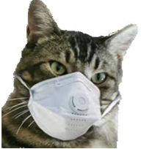

Nimrod’s Message
Editor: Cat Mews
AKA John Driscoll’s cat
He’s the President of The Central New York Technology User Group
April 2020 issue, Salt Bytes

Oh, now he tells me cats don’t get COVID-19. Do you know how hard it is to get a mask that fits me? And this “paw” washing .. you know cats don’t like water anyway. And, guess what, how do you think they take a cat’s temperature. It was bad enough using John’s thermometer.

Can’t say too much more though, I do get fed regularly and the stores don’t seem to have a “run” on “Sheba” kitty delight cat treats. Oh yea, kitties don’t use litter box “paper” either.

I have to say one thing. Sometimes it’s nice to just cuddle up and take advantage of the amount of heat our humans radiate. And, you know, things get cleaned up a lot more.
John’s been down in the basement quite often doing loads of wash.

I even get to go out on the porch once in a while. Not too far from the sliding glass door though, remember to stay between the human and the door. Don’t want to get locked out by accident. I hear it’s pretty tough in the wild.

